

**Research & Vehicle Technology**

**“Infotainment Systems Product Development”**

**Feature – Auto Hold**

**Infotainment Subsystem Part Specific Specification (SPSS)**

Version 1.1

**UNCONTROLLED COPY IF PRINTED**

**Version Date: February 20, 2017**

**FORD CONFIDENTIALF**

**Revision History**

|  |  |  |  |
| --- | --- | --- | --- |
| **Date** | **Version** | **Notes** | |
| **September 27, 2016** | **1.0** | **Initial Release** |  |
|  |  |  |  |
| **February 20, 2017** | **1.1** | **Updated Release** |  |
|  | AH-FUR-REQ-235718/B-AH Logical Signal Mapping | | CAN signal naming update. |

**Table of Contents**

Revision History 2

1 Architectural Design 4

1.1 Overview 4

1.2 AH-REQ-235635/A-Auto Hold Client 4

1.3 AH-REQ-235636/A-Auto Hold Server 4

1.4 AH-FUR-REQ-235718/B-AH Logical Signal Mapping 4

1.5 AH-REQ-235721/A-AutoHoldServer_Tx 4

1.5.1 REQ-235720/A-AHFeatureSt 4

1.6 AH-REQ-236105/A-AutoHoldServer_Rx 4

1.6.1 REQ-235719/A-AHSwitch 4

1.7 AH-REQ-235722/A-AutoHoldClient_Tx 5

1.7.1 REQ-235719/A-AHSwitch 5

1.8 AH-REQ-236106/A-AutoHoldClient_Rx 5

1.8.1 REQ-235720/A-AHFeatureSt 5

2 General Requirements 6

2.1 REQ-235883/A-Error detection 6

2.2 REQ-235884/A-Missing Signal 6

2.3 REQ-237260/A-Button Press 6

3 Functional Definition 7

3.1 Use Cases 7

3.1.1 UC-REQ-235610/A-Auto Hold turned On 7

3.1.2 UC-REQ-235614/A-Auto Hold turned Off 7

3.1.3 UC-REQ-235621/A-Auto Hold not Enable-able 7

3.1.4 UC-REQ-235627/A-Auto Hold detects system fault 7

3.1.5 UC-REQ-235631/A-Vehicle Display detects system fault 8

3.2 White Box Views 8

3.2.1 Activity Diagram 8

3.2.2 Sequence Diagram 9

4 Appendix: Reference Documents 11

# Architectural Design

## Overview

The aim of Auto Hold is to relieve the driver from having to press the brake pedal continuously to keep the vehicle stationary on any road gradient for an unlimited time. The feature is particularly helpful in stop-and-go traffic and on inclines. Auto Hold automatically releases the brakes when the driver presses the accelerator pedal or operates the clutch pedal with the intention to drive off.

## AH-REQ-235635/A-Auto Hold Client

Responsibility: Auto Hold Client among its other duties is also responsible sending Auto Hold button press information and for displaying the Auto Hold feature state, enables the users to change the state of the Auto Hold feature (such as On and Off) and notifies the server if any missing signal related to the feature has been detected.

## AH-REQ-235636/A-Auto Hold Server

Responsibility: Auto Hold Server is responsible for the main feature functionality. Basically it will reply to user requests to turn the feature On or Off or will notify the user if the feature is unavailable due to any restrictions or errors.

## AH-FUR-REQ-235718/B-AH Logical Signal Mapping

The CAN signals mentioned throughout this document shall refer to the CAN signal’s logical name. The logical names shall be mapped to their actual CAN signal names. Please use the table below to perform the mapping. The InfoCAN database file is the master file for the actual CAN signal names. Note: There may be cases where the actual CAN signal name is used in this documentation.

|  |  |
| --- | --- |
| **Logical Name** | **CAN Signal Name** |
| AHSwitch | **AutoHoldSwtch_D_Stat3** |
| AHFeatureSt | **AutoHoldSwMde_B_Ind** |

Table: Logical name/CAN signal mapping

## AH-REQ-235721/A-AutoHoldServer_Tx

### REQ-235720/A-AHFeatureSt

AHFeatureSt tells to the client the state of the feature, if it is ON or Off.

|  |  |  |  |
| --- | --- | --- | --- |
| **Name** | **Literals** | **Value** | **Description** |
| AHFeatureSt |  |  |  |
|  | Off | 0x0 | Auto Hold is turned OFF. |
|  | On | 0x1 | Auto Hold is turned ON. |

## AH-REQ-236105/A-AutoHoldServer_Rx

### REQ-235719/A-AHSwitch

AHSwitch is used by the Client to send user request to the server to turn the Auto Hold feature ON or Off or any other state, such as Faulty condition in case signal is missing by giving the switch state.

AHSwitch is generated by Client at a periodic interval. For timing information and details please refer to CAN DBC file. The signal is generated as Pressed when user touches the button and as not pressed otherwise or faulty as applicable.

|  |  |  |  |
| --- | --- | --- | --- |
| **Name** | **Literals** | **Value** | **Description** |
| AHSwitch |  |  |  |
|  | NotPressed | 0x0 | Auto Hold switch is not being pressed by the user. |
|  | Pressed | 0x1 | Auto Hold switch is being pressed by the user. |
|  | Not Used | 0x2 | Signal state is not being used. |
|  | Faulty | 0x3 | Fault has been detected from Client side. |

## AH-REQ-235722/A-AutoHoldClient_Tx

### REQ-235719/A-AHSwitch

AHSwitch is used by the Client to send user request to the server to turn the Auto Hold feature ON or Off or any other state, such as Faulty condition in case signal is missing by giving the switch state.

AHSwitch is generated by Client at a periodic interval. For timing information and details please refer to CAN DBC file. The signal is generated as Pressed when user touches the button and as not pressed otherwise or faulty as applicable.

|  |  |  |  |
| --- | --- | --- | --- |
| **Name** | **Literals** | **Value** | **Description** |
| AHSwitch |  |  |  |
|  | NotPressed | 0x0 | Auto Hold switch is not being pressed by the user. |
|  | Pressed | 0x1 | Auto Hold switch is being pressed by the user. |
|  | Not Used | 0x2 | Signal state is not being used. |
|  | Faulty | 0x3 | Fault has been detected from Client side. |

## AH-REQ-236106/A-AutoHoldClient_Rx

### REQ-235720/A-AHFeatureSt

AHFeatureSt tells to the client the state of the feature, if it is ON or Off.

|  |  |  |  |
| --- | --- | --- | --- |
| **Name** | **Literals** | **Value** | **Description** |
| AHFeatureSt |  |  |  |
|  | Off | 0x0 | Auto Hold is turned OFF. |
|  | On | 0x1 | Auto Hold is turned ON. |

# General Requirements

## REQ-235883/A-Error detection

If Client detects an error affecting Auto Hold switch display or its control, SYNC shall transmit AHSwitch = Faulty. An associated DTC shall be logged under this condition. Consult with diagnostics specs for more details.

## REQ-235884/A-Missing Signal

If Client misses signal AHFeatureSt for 5 consecutive seconds (5xRx cycle time), it shall transmit AHSwitch= faulty and display the feature as Off. A lost communication with ABS module shall be logged under this condition.

## REQ-237260/A-Button Press

The client shall generate a button press value only when the user requests a state change in the feature. The client shall not generate a button press value if the user requests the already selected feature state twice or more.

# Functional Definition

## Use Cases

### UC-REQ-235610/A-Auto Hold turned On

|  |  |
| --- | --- |
| **Actors** | Vehicle occupant |
| **Pre-conditions** | The infotainment system is powered on.  The ignition status is Run/Start.  Auto Hold switch is in OFF position. |
| **Scenario Description** | The driver clicks on the Auto Hold soft switch to turn the feature ON.  All Auto Hold enabling conditions are fulfilled. |
| **Post-conditions** | The vehicle display shows Auto Hold soft switch in switched ON position. |
| **List of Exception Use Cases** |  |
| **Interfaces** |  |

### UC-REQ-235614/A-Auto Hold turned Off

|  |  |
| --- | --- |
| **Actors** | Vehicle occupant |
| **Pre-conditions** | The infotainment system is powered on.  The ignition status is Run/Start.  Auto Hold switch is in ON position. |
| **Scenario Description** | The driver clicks on the Auto Hold soft switch to turn the feature OFF.  All Auto Hold enabling conditions are fulfilled. |
| **Post-conditions** | The vehicle display shows Auto Hold soft switch in switched OFF position. |
| **List of Exception Use Cases** |  |
| **Interfaces** |  |

### UC-REQ-235621/A-Auto Hold not Enable-able

|  |  |
| --- | --- |
| **Actors** | Vehicle occupant |
| **Pre-conditions** | The infotainment system is powered on.  The ignition status is Run/Start.  Auto Hold switch is in OFF position. |
| **Scenario Description** | The driver clicks on the Auto Hold soft switch to turn the feature ON.  Auto Hold enabling conditions are not fulfilled or Auto Hold has detected a system fault. |
| **Post-conditions** | The vehicle display shows Auto Hold soft switch in switched OFF position. |
| **List of Exception Use Cases** |  |
| **Interfaces** |  |

### UC-REQ-235627/A-Auto Hold detects system fault

|  |  |
| --- | --- |
| **Actors** | Auto Hold system |
| **Pre-conditions** | The infotainment system is powered on.  The ignition status is Run/Start.  Auto Hold switch is in ON position. |
| **Scenario Description** | Auto Hold feature detects a system fault. |
| **Post-conditions** | The vehicle display shows Auto Hold soft switch in switched OFF position. |
| **List of Exception Use Cases** |  |
| **Interfaces** |  |

### UC-REQ-235631/A-Vehicle Display detects system fault

|  |  |
| --- | --- |
| **Actors** | Vehicle display system |
| **Pre-conditions** | The infotainment system is powered on.  The ignition status is Run/Start.  Auto Hold switch is in ON position. |
| **Scenario Description** | Vehicle display system detects a system fault. |
| **Post-conditions** | The vehicle display shows Auto Hold soft switch in switched OFF position.  Display shall send faulty condition to the server. |
| **List of Exception Use Cases** |  |
| **Interfaces** |  |

## White Box Views

### Activity Diagram

#### REQ-236101/A-Auto Hold Operation

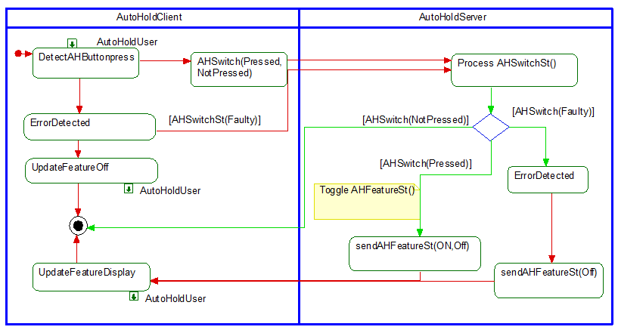

### Sequence Diagram

#### REQ-236102/A-Auto Hold Operation



# Appendix: Reference Documents

|  |  |
| --- | --- |
| Reference # | Document Title |
| 1 |  |
| 2 |  |
| 3 |  |
| 4 |  |
| 5 |  |